
DOI: https://doi.org/10.38035/dijemss.v6i5
https://creativecommons.org/licenses/by/4.0/

Job Satisfaction and Workplace Flexibility Models in Reducing Job Hopping Among Generation Z in an Agriculture Company in Karawang Regency

Eti Rusmiati¹, Endaryanto², Didin Hikmah Perkasa³
¹Universitas Paramadina, Jakarta, Indonesia, eti.rusmiati@gmail.com
²Universitas Paramadina, Jakarta, Indonesia, endaryanto1207@gmail.com
³Universitas Paramadina, Jakarta, Indonesia, didin.perkasa@paramadina.ac.id

Corresponding Author: eti.rusmiati@gmail.com¹

Abstract: This study examines the relationship between job satisfaction, work flexibility and job hopping tendencies among Generation Z employees. By exploring key factors influencing job retention, this research aims to provide insights for employers to develop workplace policies that align with Gen Z’s expectations, fostering a more stable workforce. The methodology used is a quantitative survey involving 120 respondents from Generation Z who work in an agricultural company in Karawang Regency. Data was collected using a questionnaire designed to measure job satisfaction, work flexibility, job loyalty and job-hopping tendencies. Using PLS - SEM outer model, inner model and hypothesis testing to identify the relationships between these variables. The results indicate that job satisfaction and work flexibility positively influence job loyalty. While flexibility can enhance loyalty, it also encourages job exploration. Job hopping remains common duet o attractive culture, career growth, and better pay. Thus, loyalty alone can’t prevent turnover, as Gen Z’s choices are driven by both personal and professional goals. This study explores Generation Z behavior at workplace by identifying job loyalty as mediator between job satisfaction, flexibility, and job hopping. It also addresses a gap by examining the often-overlooed agricultural sector, where workforce stability is crucial.

Keywords: Job satisfaction; work flexibility; job loyalty; job hopping; Generation Z

INTRODUCTION
Generation Z (Gen Z), defined as individuals born between 1997 and 2012, represents a rapidly growing and influential segment of the global workforce (BPS, 2020). As digital natives, this generation has been shaped by technological advancements, leading to unique workplace expectations, particularly regarding job satisfaction and work flexibility (Turner, 2015). However, a notable trend among Gen Z employees is their high propensity for job hopping – a voluntary act of changing jobs frequently, often driven by dissatisfaction, limited career advancement, or inadequate workplace flexibility (Tett & Meyer, 1993, as cited in Mahadi et al., 2020). According to the Harvard Business Review (HBR), 83% of Gen Z employees consider themselves active job seekers, with only 13% intending to stay with their current employer long-term (Waldman, 2024). This trend poses a significant challenge for organizations striving to retain young talent and maintain workforce stability.
Job satisfaction, defined as the positive emotional state resulting from the fulfilment of workplace expectations (Soetrisno, 2019), plays a critical role in employee retention. Satisfied employees tend to exhibit higher productivity, commitments, and loyalty (Wagner & Gooding, cited in Tran et al,. 2024), while dissatisfaction often leads to increased turnover and reduced performance (Robbins et al., 2008). Research has consistently identified job satisfaction as a determinant of employee retention, often associated with reduced turnover intentions (Anifah & FoEh, 2022). Factor such as work environment, compensation, recognition, and career development opportunities significantly influence job satisfaction (Abiodun-Oyebanji & Iyiola, 2023). However, studies suggest that job satisfaction alone may not be sufficient to curb job hopping tendencies, especially among Gen Z employees who seek personal growth and alignment with their aspirations (Goh, 2018).
Another critical factor influencing Gen Z employees is work flexibility, which includes flexible working hours, remote work options, and policies that support work-life balance (Waworuntu et al.,2022). Work flexibility enhances employee satisfaction, reduces stress, and lowers turnover intentions (Berber et all., 2022). However, greater flexibility may also create opportunities for employees to explore alternative jobs offering more attractive conditions, thus presenting a double-edged challange in retention strategies (Sánchez & Lopez, 2019).
Job loyalty, defined as an employee’s commitment to their organization, encompassing dedication to their role and alignment with the company’s vision and objective (Freempong et al., 2018) is often considered as a mediating factor in reducing turnover (Perkasa & Puwaranto, 2024). Nevertheless, high loyalty alone does not guarantee retention if career opportunities or suportive leaderships are lacking (Giovanni & Le, 2022)
Job Hopping, characterized by frequent job changes within a short period, has become a defining feature of Gen Z’s career trejectory (Leovani, 2022). Gen Z employees are more likely to job-hop in pursuit of better career opportunities and work-life balance (Lyons & Kuron, 2013).Although often viewed negatively, job hopping can be strategic, enabling individuals to gain diverse experiences and accelerate professional growth (Natesh & Rathman, as cited in Igbadumhe et al., 2023).
In Indonesia, where Gen Z constitutes approximately 27.94% of the population (BPS, 2020), understanding the interplay between job satisfaction, work flexibility, job loyalty, and job hopping is crucial, especially in sectors like agricultural, which struggle to attract and retain young talent (KOMINFO, 2022). Previous studies have explored these variable separately, but few have examined their integrated effects, particulary in the agricultural sector where workforce stability is critical.
Given this context, this study aims to fill the research gap by investigating the interplay between job satisfaction and workplace felxibility in reducing job hopping tendencies among Gen Z employees. Focusing on a sample of 120 Gen Z employees in a newly established agricultural company in Karawang Regency, Indonesia, the research seek to (1) analyze the impact of job satisfaction on reducing job hopping tendencies among Gen Z employee, (2) examine the role of workplace flexibility in fostering job loyalty, and (3) develop a model integrating job satisfaction and workplace flexibility to mitigate job hopping tendencies, By addressing these objective, this study contributes to the literature by offering practical recommendation for organizations seeking to adapt to evolving needs of the Gen Z workforce.

METHOD
This study adopts a quantitative research design to examine the relationship between job satisfaction, work flexibility, job loyalty, and job hopping tendencies among Generation Z employees. A survey-based approach was employed to collect data, enabling the measurement of variables and the analysis of their interrelationships. The research design is descriptive and correlational, aiming to identify patterns and associations among the studied variables.
The population for this study consists of Generation Z employees working in an agricultural company located in Karawang Regency, Indonesia. A purposive sampling technique was used to select participants who met the criteria of being Gen Z employees with at least six months of work experience in the company. The sample size for this study is 120 respondents, which is considered sufficient for quantitative analysis and ensures a representative subset of the population.
Data were collected through a structured questionnaire distributed via google form. The questionnaire was divided into four sections, each focusing on one of the key variables: job satisfaction, work flexibility, job loyalty, and job hopping tendencies. Each Variable consists of multiple question indicators. A likert scale (ranging from 1 = strongly disagree to 5 = strongly agree) was used to measure respondents’ perceptions (Sugiyono, 2006). Before distribution, the questionnaire underwent pre-testing with a small group of Gen Z employees to assess clarity and relevance. Feedback from the pretest was used to refine the instrument, ensuring that the questions were easily understood and accurately captured the intended constructs. Data collection lasted two weeks, with reminders sent to participants to endure a high response rate.
The collected data were analyzed using statistical software following these steps:
- Descriptive statistics to summarize demographic characteristics and response distributions.
- Inferential statistics including correlation analysis and multiple regression to examine
relationship between variable. (3) PLS-SEM (Partial Least Square Structural Equation Modeling) was used to validate data sampling and test hypotheses.
The reliability of the measurement scales was assessed using Cronbach’s alpha ( threshold of 0.7). Validity tests, including content validity and construct validity, were conducted to ensure accurate measurement of the intended constructs.

RESULT AND DISCUSSION
Respondent Characteristics
This study involved 120 respondents, all of whom were employees at an agricultural company in Karawang Regency, Indonesia. The sample comprised 70 female employees (58.3%) and 50 male employees (41.7%). In term of age distribution, 10 respondents (8.3%) were under 20 years, while majority, 110 respondents (91.7%) were between 20 and 27 years old. Regarding work experience, 25 respondents (20.8%) had been employed for less than one year, 49 respondents (40.8%) had 1-2 years of work experience, 27 respondent (22.9%) had worked for 2-3 years, and 19 respondents (15.5%) had been employed for more than three years.

Table 1. Respondent Characteristics
No | Gender | Age’s | Work Period
1 | Female = 70 (58.3%) | <20 yo = 10 (0,08%) | < 1 = 25 (20.8%)
2 | Male = 50 (41.7%) | 20-27 yo = 110 (0,92% | 1 – 2 = 49 (40.8%)
3 |  |  | 2 – 3 = 27 (22.9%)
4 |  |  | >3 = 19 (15.5%)
Source: Processed Data

Measurement Model Evaluation
Convergent Validity
Convergent validity was assessed using factor loading values and Average Variance Extracted (AVE). according to (Ghozali & Latan, 2015), factor loading above 0.7 and AVE values above 0.5 indicate good convergent validity. As shown in Table 2, all indicators met these criteria, confirming the validity of the constructs.

Table 2. Convergent Validity Test Result
Variable | Indicators | Ouer Loading | Information
Work Flexibility | FK1 | 0.826 | Valid
Work Flexibility | FK2 | 0.835 | Valid
Work Flexibility | FK3 | 0.776 | Valid
Job Satisfaction | KK2 | 0.760 | Valid
Job Satisfaction | KK4 | 0.745 | Valid
Job Satisfaction | KK5 | 0.776 | Valid
Job Satisfaction | KK6 | 0.860 | Valid
Job Loyalty | LK1 | 0.934 | Valid
Job Loyalty | LK2 | 0.945 | Valid
Job Hopping | JH1 | 0.806 | Valid
Job Hopping | JH2 | 0.849 | Valid
Job Hopping | JH3 | 0.810 | Valid
Job Hopping | JH4 | 0.873 | Valid
Job Hopping | JH5 | 0.814 | Valid
Source: PLS Output
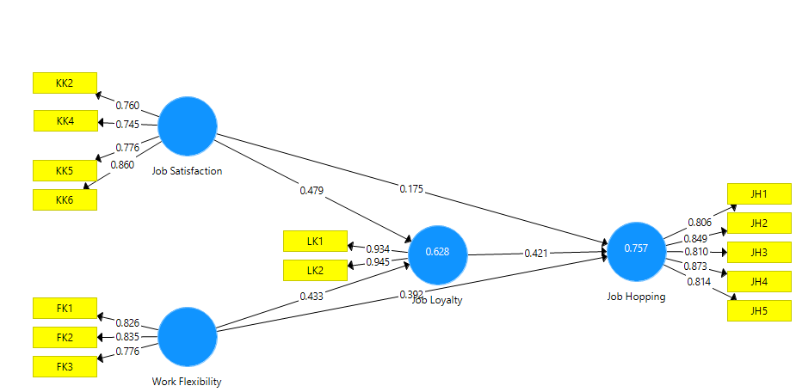
Figure 2. PLS Algorithm Result
Source: PLS Output
Table 3. Convergent Validity (AVE) Test Results
Construct | (AVE) | Information
Job Satisfaction (X1) | 0.619 | Valid
Work Flexibility (X2) | 0.661 | Valid
Job Loyalty (Y) | 0.882 | Valid
Job Hopping (Z) | 0.691 | Valid
Source: PLS Output

From Table 3, the results of the convergent validity test (Average Variance Extracted/AVE) show that each construct has met the specified criteria, with AVE values above 0.5.

Discriminant Validity
Discriminant validity was evaluated using the cross-loading method. The results confirmed that each indicator had a higher loading on its respective construct than on others, indicating no issue with discriminant validity. Additionally, the square root of the AVE values (0.813, 0.831, 0.939, and 0.787) exceeded the correlations between constructs, further supporting discriminant validity.

Table 4. Discriminant Validity Test Result
 | Work Flexibility | Job Hopping | Job Loyalty | Job Satisfaction
Work Flexibility | 0.813
Job Hopping | 0.766 | 0.831
Job Loyalty | 0.677 | 0.808 | 0.939
Job Satisfaction | 0.509 | 0.669 | 0.700 | 0.787
Source:PLS Output

Reliability Test
Composite reliability and Cronbach’s alpha were used to assess the internal consistency of the constructs. All constructs demonstrated composite reliability and Cronbach’s alpha values above 0.7, confirming the reliability of the measurement instrument.

Table 5. Composite Reliability and Cronbach's Alpha Test Results
Construct | Cronbach’s Alpha | Composite Reliability | Information
Work Flexibility | 0.743 | 0.854 | Valid
Job Hopping | 0.888 | 0.918 | Valid
Job Loyalty | 0.867 | 0.937 | Valid
Job Satisfaction | 0.795 | 0.866 | Valid
Source: PLS Output

Structural Model Evaluation
R-Square (R²) Analysis
The R² values for the dependent variable were calculated to evaluate the models’s explanatory power: Job Hopping (Z): R² = 0.757, indicating that 75.7% of its variance is explained by the Job Satisfaction (X1) and Work Flexibility (X2).
Job Loyalty R² = 0.628, suggesting that 62.6% of its variance is explained by Job Satisfaction (X1).
These values indicate a string explanatory power of the independent variable on their respective dependent constructs.

Table 6. R - square Value Test Results
Construct | R Square | Percentage
Job Hopping (Y) | 0.757 | 75.70%
Job Loyalty (I) | 0.628 | 62.83%
Source: PLS Output
Predictive Relevance (Q²)
The predictive relevance of the model was assessed using the Q² value, which measures how well the model predicts the observed values. It was calculated as follows:
Q2= 1 − (1 − R1)(1 − R2)
Q2= 1 − (1 − 0,757)(1 − 0,628)
Q2= 1 − (0,243)(0,372)
Q2= 0,910
The Q² value of 0.910 indicates that the model has strong predictive relevance, explaining 91% of the variance in the Job Hopping (Z).

Hypothesis Testing
Hypothesis testing was conducted using the bootstrapping procedure to examine the path coefficients and T-statistic. The results, presented in Table 3, confirm that:
All hypotheses were supported, as the T-statistic values exceeded the threshold of 1.96, and the p-values were less than 0.05, indicating statistically significance.

Table 3. Hypothesis Testing Result
 | Original Sample | Std.  Deviation | T. Statistic | P. Values | Note
Work Flexibility -> Job Hopping | 0.392 | 0.080 | 4.874 | 0.000 | Positive-  Significant
Work Flexibility-> Job Loyalty | 0.433 | 0.064 | 6.812 | 0.000 | Positive-  Significant
Job Loyalty-> Job Hopping | 0.421 | 0.085 | 4.965 | 0.000 | Positive-  Significant
Job Satisfaction-> Job Hopping | 0.175 | 0.071 | 2.454 | 0.014 | Positive-  Significant
Job Satisfaction-> Job Loyalty | 0.479 | 0.065 | 6.812 | 0.000 | Positive-  Significant
Source: PLS Output
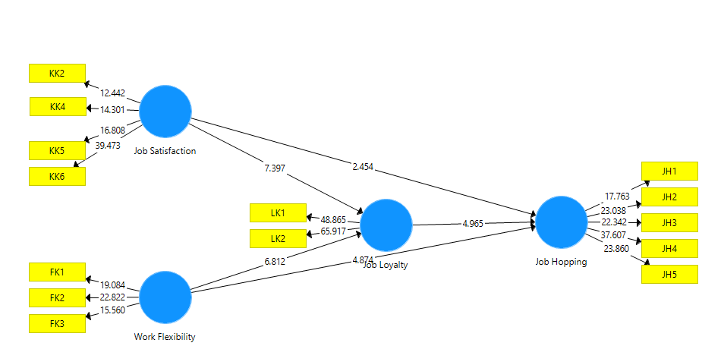
Figure 3. Bootstrapping Test Results
Source: PLS Output

Work Flexibility and Job Hopping
The findings indicate that work flexibility significantly influences job hopping tendencies (β = 0.392, p < 0.05). This suggests that while flexible work arrangements can improve employee retention, they may also encourage job hopping among Gen Z employees who prioritize autonomy and career exploration. These findings align with the notion that Gen Z seeks a workplace that supports their work-life balance (Guoqiang & Bhaumik, 2024), but if better opportunities arise, they are more likely to switch jobs.
This result is particularly relevant to Generation Z employees in the agricultural sector, as they value autonomy and work-life balance, but the nature of agricultural work may limit flexibility options. Thus companies must strategically implement flexible work arrangements without compromising operational efficiency.

Work Flexibility and Job Loyalty
These results indicate that work flexibility significantly and positively influences job loyalty (β = 0.433, p < 0.05). This suggests that flexibility work arrangements encourage employees, particularly Gen Z, to remain committed to their organization. This finding aligns with (Kgarimetsa & Naidoo, 2024), who found that work flexibility positively impacts employee loyalty in the future companies in Greater Jakarta.
For agricultural companies in Karawang, implementing flexibility in administrative roles or adapting schedules to seasonal demands may enhance employee loyalty, reducing turnover rates.

Job Satisfaction and Job Hopping
Contrary to some previous studies, this research found that job satisfaction positively influences job hopping tendencies (β=0.175, p < 0.05). This result suggests that even when Gen Z employees are satisfied with their job, they may still seek better career opportunities, company culture, or salary increases (Anjum, 2024) .
This differs from (Jules et al., 2017), who argued that job satisfaction is not a strong predictor of job hopping behavior. The difference may be due to variations in respondent characteristic, highlighting a new perspective on job satisfaction and job hopping among Gen Z employees in the agricultural sector.
The implications for organizations include the need to not only improve job satisfaction but also address career growth opportunities, technological advancement, and skill development, as these factors significantly influence Gen Z employees’ decision to stay or leave.

Job Satisfaction and Job Loyalty
The results confirm that job satisfaction significantly influences job loyalty (β = 0.479, p < 0.05), supporting the hypothesis that satisfied employees are more likely to remain in their organizations. This is consistent with (Sharma, 2019), who emphasized the role of leadership and work environment in fostering loyalty.
In the context of the agricultural sector, factors such as job security, modern technology adoption, and alignment with employee's career aspirations are crucial for enhancing job satisfaction and increasing employee retention.

Job Loyalty and Job Hopping
Job Loyalty was found to have a significant positive impact on job hopping tendencies (β = 0.421, p < 0.05), indicating that employees with higher loyalty level may still choose to leave their current organization. This unexpected result suggests that loyalty here may reflect employees’s confidence, strong networks, or valuable skills gained in the company, factors that make them feel ready to seek new opportunities. For agriculture company, this highlight the need to reframe retention strategies: loyalty alone is insufficient to curb turnover. Providing competitive career progression, maintaining open communication about future prospects, and offering tailored development opportunities could help convert loyalty into long term-commitment (Choi Sang Long, 2012), particularly among Gen Z employees.

CONCLUSION
This study explores the relationship between work flexibility, job satisfaction, job loyalty, and job hopping among Gen Z employees in a newly established agricultural company in Karawang Regency. The findings indicate that work flexibility positively influences job loyalty but also increases the likelihood of job hopping. While flexibility work arrangements enhance employee commitment, they do not entirely prevent Gen Z employees from seeking better opportunities elsewhere. Similarly, job satisfaction plays a crucial role, significantly affecting both loyalty and job hopping tendencies. Even employees who report high job satisfaction may still leave if they perceive better prospects in terms of work culture, career growth, or salary. Ultimately, the relationship between job loyalty and job hopping remains complex, as employees may still switch jobs when external opportunities align more closely with their personal and professional aspirations.
To effectively retain Generation Z employees, organizations must implement a holistic retention strategy that integrates work flexibility, career development, and a strong workplace culture. First, enhancing career development opportunities is essential. This can be achieved by establishing structured career paths with clear milestones and promotions to encourange long-term commitement, alongside providing mentorships programs and upskilling initiatives that align employee growth with organizational goals.
Secondly, work flrexibility should be optimized without compromising stability. Organizations are encourange to offer tailored flexibility policies that address individual needs while ensuring team cohesion. At the same time, flexibility should be balanced with clear, performance-based incentives to maintain employee engagement and retentions.
In additons, strengthening compensation and benefits play a vital role in retaining young talent. Providing competitive salaries that reflect ecmployee contributions and industry benchmark, along with implementing retention-focused incentives such as bonuses, stock options, or additional leave, can significantly enhance job satisfaction.
Fostering a positive workplace culture is equally important. A supportive and transparent work environment that builds trust and encourage engagement will contribute to greater loyalty. Open communication between employees and management is also key to addessing concerns practively and collaboratively.
For Generation Z employee, developing self-awareness and engaging in strategic career planning are critical. While job flexibility and satisfaction matter, prioritizing long-term career growth is essential. Open discussion with management about career expectations and personal aspirations can lead to a more stable and mutually rewarding employement relationship. Lastly, future research should explore additional factors influencing job hopping behavior among Generation Z, such as workplace technology, leadership style, and social values, to provide a deeper and more comprehensive understanding of this emerging workforce dynamic

REFERENCE
Abiodun-Oyebanji, O. J., & Iyiola, O. M. (2023). Motivation, Job Satisfaction and Turnover Intention Level of Academic Staff in Private Universities in Southwestern Nigeria. Education, Language and Sociology Research, Vol. 4, No. 3,(2023).
Anifah, A., & Ehj, Foeh. (2022, 09 22). Faktor Pengaruh Kepuasan Kerja Dan Loyalitas Kerja. Jurnal Kajian Ilmiah.
Anjum Sabahat. (2024). Exploring Job Preferences Among Generation Z: Trends and Implications. Quest Journal. Journal of Research in Business and Management, 180-187.
Berber, N., Gasic, D., Katic, I., & Borocki, J. (2022, April 10). The Mediating Role of Job Satisfaction in the Relationship between FWAs and Turnover Intentions. MPDI, 14(8)(2022).
BPS. (2020). Jumlah Penduduk menurut Wilayah, Klasifikasi Generasi, dan Jenis Kelamin, Indonesia, Tahun 2020. Retrieved from Sensus Bps: https://sensus.bps.go.id/topik/tabular/sp2020/2/0/0
Fre empong, L. N., Agbenyo, W., & Adjei, P. D. (2018). The Impact of Job Satisfaction on Employees' Loyalty and Commitment: A Comparative Study Among Some Selected Sectors in Ghana. European Journal of Business and Management, 10(12)(2018).
Ghozali, I., & Latan, I. (2015). Partial Least Squares Konsep, Teknik dan Aplikasi menggunakan program smartpls 3.0 untuk penelitian empiris. Badan Penerbit UNDIP(2015).
Giovanni, V. F., & le, M. (2022, 01 30). Pengaruh Lingkungan Kerja dan Kepuasan Kerja Terhadap Loyalitas Karyawan di Industri Kreatif. Jurnal Manajerial Dan Kewirausahaan, 4(1)(2022), 232-242.
Goh, D. E. (2018). A workforce to be reckoned with: The emerging Pivotal Generation Z Hospitality Workforce. International Journal of Hospitality Management, 73.
Guoqiang Zhang, & Bhaumik Amiya. (2024). Work-Life Harmony and Retention of Employees: A Review of The Impact of Flexible Work Arrangements. International Journal of Advancement Research, 2(2), 31–38.
Igbadumhe, A. F., Akinbo, T. M., & Adepoju, O. O. (2023, 07). Predictors of Job-Hopping Intention and Academics' Engagement in Southwest. Nigeria: A Moderating Role of Generational Diversity. Lead City Journal of the Social Sciences (LCJSS), 8 (No. 2)(2023).
Jules, N. J., Ghazali, H., & Othman, M. (2017). Job Satisfaction and Job-hopping behaviour among employees of casual dining restaurant. Journal of Tourism, Hospitality & Culinary Arts (JTHCA), 9(2)(2017), 571-582.
Kgarimetsa S. Tebogo, & Naidoo Calvin. (2024). Effect of employee recognition and flexible working arrangement on Generation Z retention. SA Journal of Human Management, 227.
KOMINFO. (2022, 10 03). Angkatan kerja produktif melimpah. Retrieved from Kementerian Komunikasi dan Informatika Republik Indonesia.
Leovani, E. (2022, 03). The Impact of Job Hopping on Career Development of The Millenial Generation. Jurnal Keuangan dan Bisnis, Volume 20 No 1(Maret 2022), 84-92.
Lyons, S., & Kuron, L. (2013). Generational differences in the workplace: A review of the evidence and directions for future research. Journal of Organizational Behavior, 35(S1), S139-S157.
Mahadi, N., Woo, N. M., Baskaran, S., & Yaakop, A. Y. (2020, 04 14). Determinant Factor for Employee Retention: Should I Stay? International Journal of Academic Research in Business and SocialSciences, 10(4)(2020), 201–213.
Perkasa, D. H., & Purwanto, S. (2024, June). Job Hopping Behavior In Millenials. IJAMESC, Vol. 2 No. 3,.
Robbins, S. P., Judge, T. A., Millet, B., & M. B. (2008). Organisational Behaviour (7th ed.). Pearson Australian.
Sánchez-Hernández, M., González-López, Ó., Buenadicha-Mateos, M., & Tato-Jiménez, J. (2019, 12 15). Work-life balance in great companies and pending issues for engaging new generations at work. International Journal of Environmental Research and Public Health, 16(24)(2019), 5122.
Sharma, M. (2020, February 15). Job Satisfaction and Employee Loyalty: a study of working professionals in Noida NCR. JECRC University, 15.
Soetrisno, E. (2019). Manajemen Sumber Daya Manusia. Prenadamedia.
Tran, H. N., Le, D. V., Hai, Y. V., Kim, H. D., & Thi Yen, N. N. (2024). Exploring Job Satisfaction among Generation Z Employees: A Study in the SMEs of the Mekong Delta, Vietnam. Journal of Chinesse Human Resources Management, 15(1)(2024), 110-120.
Turner, A. (2015). Generation Z: Technology And Social Interest. Journal of Individual Psychology, 71 (2)(2015), 103–113.
Waldman, E. (2024, September 2). How to Explain Job Hopping in an Interview. Retrieved December 4, 2024, from Harvard Business Review: https://hbr.org/2024/09/how-to-explain-job-hopping-in-an-interview
Waworuntu, E. C., Kainde, S. J., & Mandagi, D. W. (2022, 12 03). Work-Life Balance, Job Satisfaction and Performance Among Millennial and Gen Z Employes: A Systematic Review. Society, 10(2)(2022), 384-398.
Zhang Yanlu. (2024). Career Development, Incentive Mechanism, and Employee Loyalty: Basis for Employee Productivity Framework. International Journal of Research Studies in Management, 153-167.
Choi Sang Long, M. A (2012). The Approached to Increase Employee’s Loyalty: A Review on Employee’s Turnover Models. Australian Journal of Basic and Applied Science, 6(10): 282-291

